Foundation for Virtual and Augmented Reality Systems
Prof. Samit Bhattacharya
Department of Computer Science and Engineering
Indian Institute of Technology, Guwahati
Week – 01
Lecture – 03
Lec 3: Application Domains and System Categories
Hello and welcome to the NPTEL MOOCs course on Foundations for Virtual and Augmented Reality Systems. We are currently discussing applications and system categories as part of lecture 2. Earlier we talked about VR applications. So, we will be continuing our discussion on that topic. So, we have so far covered applications related to VR and VR system categories.
Now, let us continue our discussion and talk about applications related to AR and AR system categories. Just a quick recap of the use forecast. We have already seen this forecast many times and just to sum it up. There is huge potential for extended reality technologies in different application domains including video games, healthcare, engineering, live events, video entertainment, real estate, retail, military, and some more.
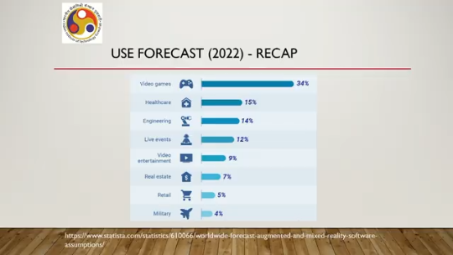
And the statistic also talks about, apart from the percentage of systems in that domain, it can also give an indication of the kind of money involved even if the percentage may appear to be less. Overall, huge potential as we have repeatedly discussed. Now, let us quickly have a look at AR applications. The forecast that I have shown earlier is related to both VR and AR applications.
VR applications we have discussed earlier, let us quickly have a look at the relevant AR applications. Now, the first thing that we should keep in mind is that while we were talking about VR, we emphasized the term immersive experience; in the case of AR, that is not mandatory. We do not pay much attention to the immersive experience; rather, we pay more attention to augmentation of real-world content with digital content. And such augmentations have many applications. We have AR applications in archaeology.
Say, for example, if you look at this figure, you can see that there is something which is not visible with the naked eye, but we can add it on our screen. So reconstruction of lost structures can be a very interesting application area. Also in architecture, we can view the architecture, we can augment it with various information, and we can actually play around with the architecture through AR applications. Industrial manufacturing, we can have important applications. For example, in this figure, in this image, as you can see, somebody is getting to see things while repairing or trying to troubleshoot some component of an industrial setup through AR applications. Commerce, particularly the e-commerce space, has a lot of AR applications, which is one of the motivational factors for this metaverse concept. Gaming, like VR, in AR also we can have a lot of gaming applications.
One famous example is Pokemon Go. Medical, again like VR, we can have many medical applications. We will see later. And there can be many more such applications. Now let us have a quick look at a few interesting applications to give you an idea of
what kind of things we are talking about here. Say one airport passenger app, Gatwick Airport, it was an old system of course. Now, what happened is that in that airport, 2000 plus beacons were placed at different points in the terminal, the passenger terminal, and through the app, the passenger can get to know where exactly he or she is and in which direction he or she needs to move to reach the desired terminal.
For large terminals that are commonplace nowadays, these types of apps are very helpful. IKEA, a famous furniture company. Now, IKEA has got one app, the IKEA Place app. It allows you to scan your room and design the space by placing IKEA objects in the digital image of your room. That in turn can give you some idea of how your room will look if you buy the products.
So, it is again a kind of customer experience before making a purchase, before buying something. So, you can actually test, the idea of purchasing particular pieces of furniture and placing them in your room and deciding whether to buy it depending on how it looks or whether you are satisfied. Now, Dulux also has a visualizer app similar in nature that is before you buy the paint, you can actually paint your walls digitally. on a screen and see the effect and based on that you can make your choice whether to go for buying the paint or not.
We can have interesting other applications also say for example, we can have a tape measure to I mean an augmented reality application where we can use a virtual tape measure That can be used inside the room or outside the room. You do not need to carry a physical tape to measure heights of objects or lengths of objects. You can use your mobile for doing that by having this app installed on your device. Similar to this paint application or this IKEA furniture app, similar other apps are also there, say for example, Sephora cosmetic company came up with this app idea that by using the AR technology, a customer can try out different looks and depending on the level of satisfaction can decide to buy the product with the right color that satisfies the most. They can virtually try out those cosmetics on their digital appearance, digital face and different parts of the face to make an informed choice before actually purchasing the product. So these types of apps are very common in AR where different customer experiences are provided before making a purchase decision. A similar app is made by Rolex, where you can try out different watch models on your digital representation of your hand, that means your hand.
And then, depending on your level of satisfaction, whether you are satisfied with the look and feel, you can actually go for buying it. These are primarily from a customer experience point of view. In healthcare, there are many interesting applications that have been developed using AR from medical training to telemedicine options that enable medical professionals to interact with patients. An interesting application is to get real-time information to treatment areas to support diagnosis, surgery, and treatment plans. For example, AccuVein, a handheld device which has AR applications, can scan the vein network of a patient that leads to a 45% reduction in escalation.
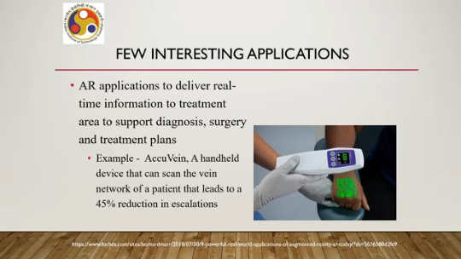
So, it can tell what the situation is, what the condition is. By pointing the device on the surface area of the skin, the internal vein network can be visualized by the user and then depending on that, the treatment course can be decided. So, those are some of the interesting applications. There are many more such interesting applications. Whatever applications I have talked about, they came earlier, they came sometime back, but the modern applications are many more and many of the earlier applications have been revised, refined, and came up in modern avatar, which are better in performance as compared to the original versions. But as you can get some idea, so AR, can be used to basically come up with many interesting application areas. Now, like VR, what we have done earlier in discussions related to VR, let us do similar things for AR. So, what kind of categories can we create for AR applications?
Unlike in VR, where we primarily focus on, Psychological experience in AR since experience or immersive experience is not that important for categorization; we have to rely on the technology side. So, technologically, we can have broadly two categories: one is marker-based AR applications; the other one is markerless AR applications. Now, markerless AR application. can have four subcategories: location-based, superimposition, projection-based, and outlining-based.
Let us have a quick look at each of these categories. Let us begin with marker-based. Now, as the name suggests, this type of application uses markers to trigger an augmented experience. That means there will be some sort of markers in the environment. When we point our device towards that marker, the digital content will be augmented on the screen view of the real world.
For example, here you can see in this figure there is one QR code-like thing. When you are pointing your handheld device, like this tab here, towards that marker, you get to see a digital augmentation, that is, this type of, say, some furniture at that spot. So you can basically check for yourself if you put furniture of this sort there, how it will look like. Now the furniture is placed where the marker is. So once your device detects the marker, then the desired augmentation is done at that point.
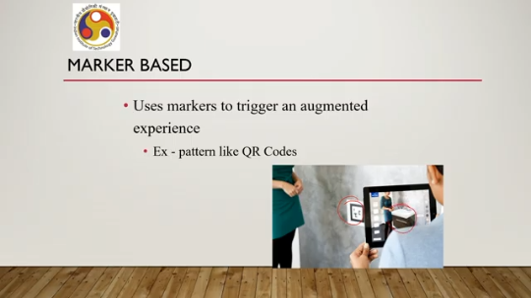
So QR codes can be one such marker. There can be other markers like simple color codes, color bars, fiducial markers; many things can be there. Now, marker-based applications are easier to make, easier to build. However, they are difficult to maintain. Markers are prone to damage.
So, once it is damaged, your app may not work. As opposed to these, we have marker-less applications. Now, these are more versatile. You do not need to place any marker anywhere in the physical world and things can be done based on computer vision techniques. So, marker-less applications are more versatile.
They allow the users to decide where to put virtual objects. Now there are subcategories of such markerless applications. One of these subcategories is location based. Here the application relies on some sort of sensor, say for example GPS sensor, to detect the location of the user with respect to a reference frame and depending on a specific location. Digital content is augmented on the real world view of the scene and that location will be provided by the sensor, the location sensor.
A common example is GPS based sensors, GPS sensors. Say for example, you are walking along a road with this view on your mobile and once you reach a specific Location reported by your GPS, something automatically appears. Say, for example, here, as you can see, this object appears on your screen, which is the digital augmentation of the real world view based on the location. Then we have superimposition based applications.
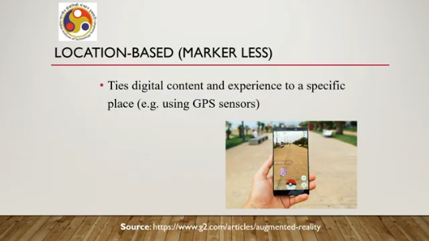
So, in this type of AR application, the object in the physical world, one object or multiple objects, are recognized using computer vision techniques and then we can augment digital content depending on the recognized object. Say, for example, in this room setting we have detected, say, this table and some chairs, and based on that we can augment another chair here as shown in this small animation. So, this is superimposition based.
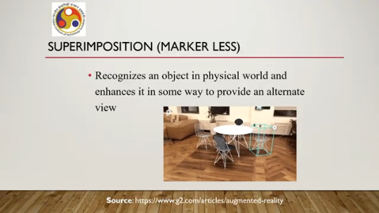
So, we are superimposing digital content on a real world scene depending on recognition of objects. Then we have projection based where we use light projectors. Now, such projectors can project digital graphics, digital characters, digital content onto an object or surface. It can be a space also.
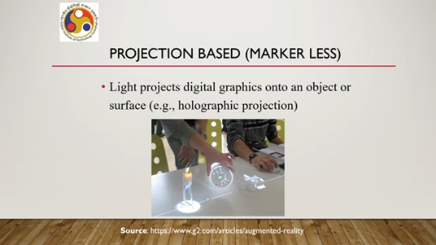
Say, for example, holographic projection or it can be on a surface. Finally, we have outlining applications. These again use object recognition to recreate the user's immediate surroundings. So, for example, while driving in low light conditions, you can augment the view that the driver gets with other cars around which may not be visible to the driver due to low light conditions.
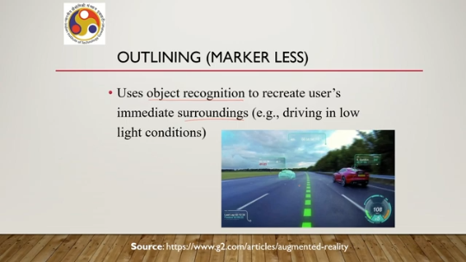
You can digitally enhance the scene with the cars that are not clearly visible to the naked eye, as shown in this figure. So, that is another type of markerless augmented reality application. So, in summary, what we can say is that we learned about different applications. both in VR and AR. Also, we talked about system categories.
For VR, experience is important; the psychological aspect is important. So, based on experience, we have talked about three categories of VR systems: non-immersive, semi-immersive, and fully immersive. Whereas, that type of psychological is not very important in AR. So here, when we talked about system categories, we primarily focused on technology.
Depending on the technology used to develop and deploy the systems, we talked about broadly two categories: marker-based and markerless. Marker-based are easier to make. They rely on simple algorithms. However, Markers are difficult to maintain unless it is a very sanitized environment, say inside a museum.
Well-attended environment is required to maintain the markers; otherwise, in outdoor settings, they are prone to damage. To overcome that, we can go for markerless techniques. Primarily, they rely on computer vision. They may rely on other sensors, like GPS sensors, in case of location-based applications. Computer vision-based applications include superimposition-based and outline-based.
Whereas projection-based techniques, such as holographic projection, can be used in AR application development, as we have seen. So, these are broadly different system categories in AR and VR; we have also talked about different applications. So, if you have noticed, the applications, more or less, broad domains are similar. However, in VR, we talk of immersive applications, whereas in AR, we do not put much emphasis on immersive applications. Instead, we focus more on other types of applications which rely on augmenting digital content onto the real-world view.
In our next lecture, we will talk about some definitions. So far, we have mentioned terms in a very loose manner, in a very broad way. We will learn a more precise way of defining these terms, say VR, AR, MR, or other concepts like immersion, in the next lecture. Once those definitions are covered, it will be easier to discuss. in a more unambiguous manner, the relevant concepts and their applications.
So, that is all we have to discuss under this topic. So, on applications and system categories. So, we have come to the end of our second lecture. I hope you have enjoyed the discussion and have learned the concepts I wanted to present.
So, thank you. Happy learning. See you in the next lecture.

